TESTING PAPER MANAGEMENT NOTES:

THINGS NOTICED AND WANT TO CHANGE
- After logging in with user department the main icons cards إدارة الإجازات – إدارة الأجهزة - متابعة المستلزمات want it to only appear for the admin/IT role DONE
- After the admin/IT login
  - Request new paper page needs to add department name from department table in the القسم المستفيد DONE
  - Need to add new tab for seeing the last issued and filter with departments and see every pending and issued request and its date (not the approved by dean date only the issue date and add another filter for the (issued – requested still not approved)) DONE
  - Can alert be notification as soon as admin enter the paper management icon it appears as notification (alert) that this specific paper type is low NOT TESTED YET
  - Another page for the admin/it reports DONE
    - Can select range of the date by month and year to generate report on the department name and the amount of paper issued in that period الاجمالي table like
    - Monthly report
    - Yearly report
    - And to be printable and in Arabic
    - A place for the CEO signature (CHANGE THE TEXT AS THE PICTURE)
- Making the password hashed in the database DONE
- Building a add user or change password and use the hash password thing built in the code or change if it need to be changed for the admin only the it person only access the rest. DONE
- Add colors like red when the password isn’t right DONE
- the login button color DONE
- the requests lists being a dark color and light color for readability DONE
- making the tab different color DONE
- change login look and delete every emoji from each title DONE
- after going to the paper management and the card of counting the total requests being pending and so on being in its color (orange – blue – green – purple) DONE
- change the مخزون name tab to المخزن DONE
- make the adding inventory center of the page DONE
- the report page make it into a table not only when its printed (also on the page itself being in a table) and remove the total only keep a4 column and a3 if the department request a3 papers if didn’t don’t add it DONE
- Add notification of when new request come in add it for admin/it/dean on the home page DONE
----------------------------------------------------------------------------
Things concerned about
- Two requests at the same time making a bug or not DONE
- How will I make it into actual web app to give link to each department and all have to put data into the same database. FIGURED FOR NOW
- Fix the code DONE

Things changed
- First the logic of the database the after department request it holds the paper inventory in the database it should only decrease (gets hold the quantity after the paper gets issued DONE
- Every department have fixed number of issue paper and they cant request more than its specific quantity it they did the request don’t go through and make a message that they aren’t allowed to they cant request above overall like this department have 5 they cant request 10 they can request 2 then 3 for ex but max is 5 DONE
- The admin/it person can change the number of the paper requested number DONE AS LOGIC
- Change the workflow of the request until issued the department request it gets first to the it/admin then they write notes can change the quantity (not always but they have the option to) and everything then approve it sending it to the dean and another dean both to approve it again then gets send back to the admin/it to issue it DONE
- A confused requirement the department don’t get to see there requests but they get to see a note that there request quantity changed? DONE

======

Things wanting change in UI

Admin login
- لوحه التحكم ال icons بتاعت الطلبات قيد الانتظار can it be made with the color itself like orange blue DONE
- Also the requests can it have icon with the color similar to its icon DONE
- أحدث طلبات الصرف can it be a table and not unreadable that and the حاله being in Arabic showing to the user in Arabic ]’542852*/895623*-9+6
- 3.
- 01
0The tool bar or the dashboard being in different color and not white
zjhhhghghghghghghgfgxzzEach filter we have from date to date make it a drop down selection and not typing type
- If we selecting something from the dashboard highlight it so we can know which tab we are in
- مراجعة طلبات الورق tab can we make it pretty and the filter and stuff make it organized and in the same size and the table make it readable and add the color and another color to make it readable
- سجل الطلبات الشامل 📜 make it readable status being in Arabic and so on تقارير استهلاك وحركة الورق 📊 here is the same
- تقارير استهلاك وحركة الورق 📊 make it into a table and remove تاريخ آخر عملية صرف لكل قسم it should be the total they issued in the selected period
- The printable report should look like this 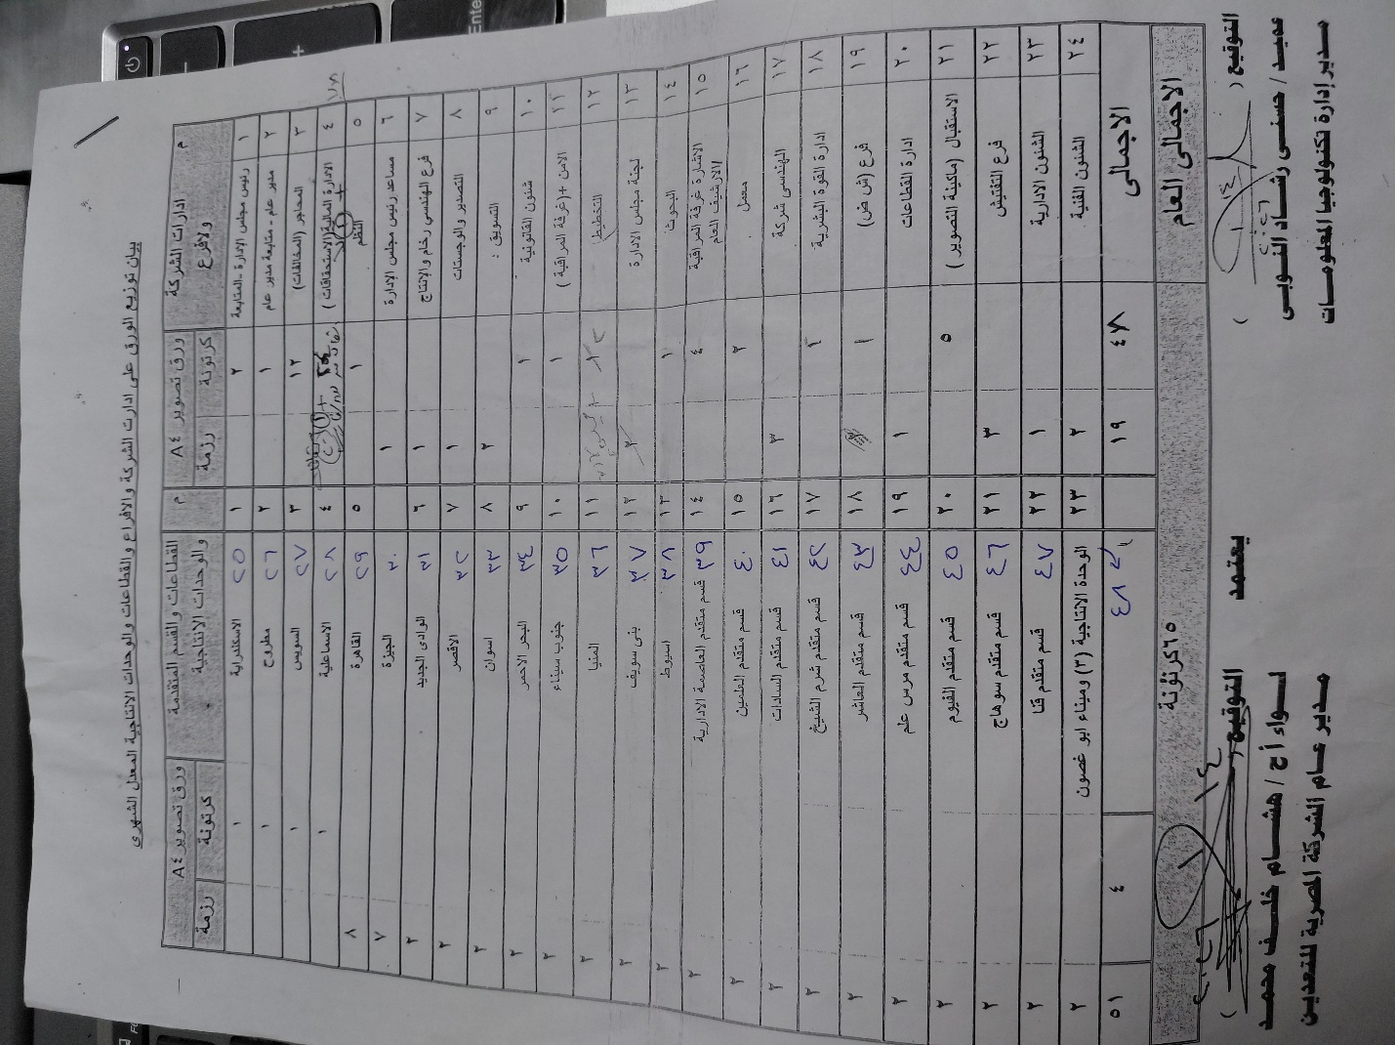
- The report page the filter is not needed what is needed is the select under it and it need to select from month to month and select the year or select 1 month and that’s it and it gets calculated DONE
- The home button (الرئيسيه) should bring the user to the main subsystem pages DONE
- Manage users need to change/need to be done (it doesn’t open) DONE

DEAN PAGE
- Dean shouldn’t see the icon to click even on to do new request and to see the requests make the filter pretty organized and make the table readable and add color to the action
- BCrypt.Net.SaltParseException: 'Invalid salt version' IN CODE when I try to login with dean 2 DONE

DEPARTMENT PAGE
- Department shouldn’t even see the request icon DONE
- Remove لوحه التحكم tab from the taskbar

General
Inside paper management It have departments and the its users only
- I want admin to have this adding department too when they add department they automatically go to the user and it’s fixed that they have department role and cant be changed and then they add the user
- Role is fixed in this page on the department and remove its selection
- I want to the admin to that he can also change the quota of each department (that is reset every month)
- but also add exception if the department wants more than its quota they have message that its above there quota and if they want more they make request to the CEO (all in Arabic) DONE BUT NEED ULTER
- Have option to delete the account too
For the admin on the home page -> have all users and it’s called (Admin Users)
Change screens completely )FOR ADMIN/IT)
- PAGES (مراجعه المخالفات –قائمه الصرف - سجل الطلبات – اخر قسم صرف) need to be deleted/ combined in one page that shows all the requests
  - The main page showing every request first from the latest in the top the it person click on a button of the details and it open a window smaller than the main website showing the details of the request and can change the quantity in this page and under that request a history of that specific department with all the requests they made before issued or not and the total on top and in the end there is a button to approve it and send it to the dean and another button to refuse
  - Another page adding for the dean the same 2 screens as before of table showing all the requests look at the details then it shows all department requests before and the total on the top and they can approve or not
  - Another tab for the admin/it
    - To look at all the dean approval requests (after the dean approved) so they can issue the request
  - Adding the filter normally on the top make it organized and the same size the from to date should be a drop down calendar selection
====
After version 8 testing
- The change in the department quota doesn’t appear on the screen but it appears in the database
- The quota they should choose the paper type with there quota and not only 1 quota bec there is different papers make it dynamic so when new papertype added I don’t need to change in the database
- Status in the small window should be in Arabic
- IN ADMIN HOME PAGE remove the admin users card and only it being on the top

- When both dean accept or reject add the option for them to add a note
- On the main table (dean role) I only want them to see the things they should approve on and not everything but when they click on details button everything else appears
- The status color need to be added inside a block with colors
  - قيد اعتماد المقدم محمد - قيد اعتمادالعميد حسني both in color f3722c
  - مرفوض in color f94144
  - تم الصرف in color 90be6d
  - قيد المراجعه f9c74f
- Fix filter make it all organized and same size
- In admin/it put the button of approval and remove on the screen center in the end
- The notification part should be a pop up thing that a new request from this department came or this department need to issue the dean approved the request and so on and not a tab I get to go inside
- Fix the table ui to make it the same as the one in the home website and remove the total from each row only keep total on the end
- The report part remove the url from the bottom of the paper – remove the total from each side of the department (الاجمالي) only add total at the end of the table – remove the date of today and only add the date of what is this

=========
ADMIN/IT PAGE
- There is a message with disabling the account but there is no button for that in user management page DONE
- Adding new account page add option to choose the role of the account
- Notification should appear on the system outside not inside paper management also the notification of low paper stock on the outside as a pop up on the right then it disappear DONE
- The status color need to be added inside a block with colors
  - قيد اعتماد المقدم محمد - قيد اعتمادالعميد حسني both in color f3722c
  - مرفوض in color f94144
  - تم الصرف in color 90be6d
  - قيد المراجعه f9c74f
  - جاهز للصرف #2DCCFF DONE
- In department management page every department make a select down (an arrow beside every department when we click on it it open the rest to then edit the paper type quota) DONE
- Make the account approver be looked until I click on the button تعديل then it get open to select the account and save it after saving it it gets locked again DONE
- After adding department and it redirect me to the user page which is already done go back to the department management DONE
- When we add department and it goes to adding user in that department make the department select down choice be locked and the role department locked (we cant change them)
- The filter should be like this but on our system DONE 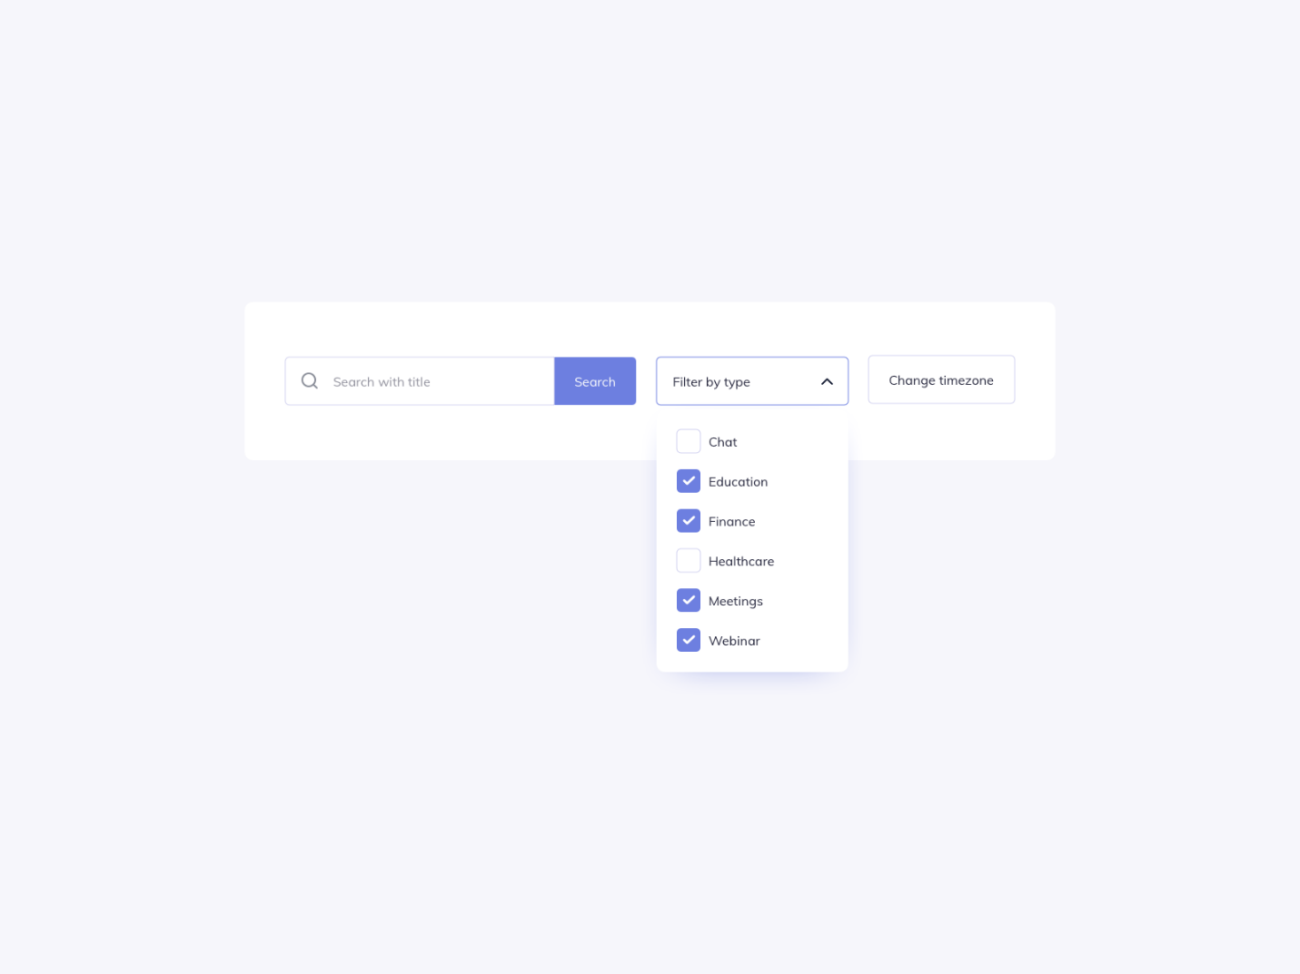
- Request/Inventory should be aligned and taking the whole page and be responsive
- Remove the date in the pages that have filter and add the same ui date from to in the report add it to every page that have filter DONE
- Concern if we have whole 48 department in the printable how it will look like
- In /Request/IssueQueue page remove the approved from and add details button see the notes of the approvers and to change the quantity and add notes too and add option to issue it from inside the pop up window and the outside table button
- The pop up screen move the button to the bottom next to the refuse button
- In the pop up window show the text details if the المقدم محمد or العميد حسني add notes
DEAN PAGE
- The filter edit again
- The main table in the request/pending should be like this but when we click on the details button it should show the whole request that department did before like the admin/it page
- Remove the لوحه النحكم icon from the dean page
All pages remove the tabs color and add this color <thead class="bg-slate-800 border-b border-slate-900 text-white font-bold"> change every green color of this system to this color

Everything else, roughly grouped by size:
Small (quick, self-contained):
- Status badge colors (you gave exact hex codes — easy)
- Move popup buttons next to the reject button
- Show approver notes text in the popup if present
- Remove the dashboard icon from the Dean page
Medium:
- Collapsible/accordion department cards + lock-until-"تعديل" for approver assignment
- Notifications moved outside Paper Management + low-stock toast popup
- Replace every page's date filter with the Reports-page from/to style
- Request/Inventory page responsive layout
Bigger (touches many files or is a real redesign):
- Global color pass: remove tab colors, thead → bg-slate-800, every green (in the system not status) → your new color
- IssueQueue redesign (details popup with notes/quantity-edit/issue-from-popup)
- Dean's Pending page redesign (details popup showing department history)
- Filter UI redesign (blocked on the screenshot)
- Option to delete department
- Adding a table to track when the inventory came and creating one with ui and how much was added the paper type and the date
- Report add option to select a paper type to print if so
- Make add new paper type in the same page
TESTING THE WHOLE WORKFLOW
In the search of department management the search doesn’t work besides the search ui have both search and البحث عن قسم so we need to delete the search
And also fix the dropdown ui
Also the notes if its written should be appearing in order like deoartment add notes then it forst approval if added notes and then if مقدم محمد added notes then if العميد حسني added notes all that should be in order and appearing if added

okay but where is the option to delete the department and also something else i want to add is that Also the notes if its written should be appearing in order like deoartment add notes then it forst approval if added notes and then if مقدم محمد added notes then if العميد حسني added notes all that should be in order and appearing if added i want to make sure its fully developed also when i search by the date i cant go back??? also the search by status in issue queue is not needed so lets delete it but in the review queue it doesnt work? like this looks better

=========
Things to add/ change
The department would have another tab to see their request status bec when its all done and wasa about to be issued the departement person will come to collect its stuff until it do issued -> the request get removed from the ui for the department
And another tab of if they want to make an exception request and it appear for the it/admin/approver to appear in different color like just bec its an exception not like other requests

When the request get rejected for any other reason and it goes back to the it/admin they can review it and change according to the approver notes or they reject it completely so it closes if not they review the notes and resend it for approval
The change in the quantity only before sending it for approval and not when we get to issue it too
Remove the status search from the dean page
And remove the instant written search from all the filters search

okay so today i presented everything to my manager and he told me alot of things to change and critsize me bec i didnt make a flow chart or database drawing and all that and didnt finish the document which is fine but its depressing that i lacked like that and wasnt perfect? anyway i will give you the latest code and what i need to add or change

The dean page doesn’t show the tables and other requests when we click on details button

okay thank you so much for being gentle and patient and giving me step by step and helping me with everything and giving me the best code too i want to change these When the request get rejected for any other reason and it goes back to the it/admin they can review it and change according to the approver notes or they reject it completely so it closes if not they review the notes and resend it for approval The change in the quantity only before sending it for approval and not when we get to issue it too Remove the status search from the dean page And remove the instant written search from all the filters search

things to change again
when I write notes from the department why is it the same written in the text box of the it review it should be saved as department note and the text box for the admin should be empty so that it/admin can write notes for himself and to be the notes form admin/it is different from the notes written from department and so on for approver 1 and approver 2 all of them have separate notes and that’s it
Another thing is that the notes from the it review didn’t show for the approver 1 or 2 it doesn’t even exist? It should be showing if they put notes if they didn’t then don’t show anything
The resent request after it got rejected doesn’t show in the review queue table to take action on and we need to add an Arabic name describe the status of it note it did show when I checked all the status filter we need to add it in the fiter to show
Every note should be put ontop of each other like and be labled this is from it when he reviewed this is from approver 1 all withen their name and to be arranged if one didn’t add notes then simply don’t show it
And label who refused the request and there note so its all known

تمت الموافقة على الطلب بنجاح وهو الآن جاهز للصرف من قبل قسم IT. This should be removed and only is تمت الموافقه علي الطلب
Bec we are waiting for the other approver to approve of this and not that its ready to be issued
Remove the editing part from the pop up window in issue queue table

===
AFTER TESTING
- In the case of only approver
The note from it didn’t show for the approver 1 the department note only showed
In the approver 2 the note from department and note from approver 1 only showed and not the it note it all should show
IN the issue queue only the department note shown when it should be all the notes being shown if exist
- In the case of the request being refused and it being re reviewd
In the case of refusal the it note did show in the request and the note of the refuseal
هذا الطلب مرفوض من أحد المعتمدين. راجع الملاحظات أعلاه، ثم أعد الإرسال بعد التعديل أو أغلق الطلب نهائياً. This message should show who refused the request being ألمقدم محمد or العميد حسني same as note
The note after sending the request back all the notes should show again
The final thing is that we want to show everynote everywhere except for the department page
=======
okay all good except for when approver 1 refuses the request and the it write a note it override the the original it note and can the note of approver 1 and 2 being placed after the refusal note like i want everything in order thats it there is a case of that i want to test but can you prepare for it like what if approver 1 refused the request then the it re review then send it again the approver 1 accepted but then the approver 2 refused and it goes back to it then they start the workflow again so then if notes are written in all of this will it all show in order???

====
okay that سجل الاحداث works fina so can we just change something first lets remove notes that is after سحل الاحداث from the ui and make that سجل like colors like the notes one just change in the ui thank you it works fine but wait i found something this is my testing that i reached سجل الأحداث
- تقديم الطلب2026/08/12 07:38 النظام this a note from department
- مراجعة IT2026/08/12 07:39 ADMIN (Admin) this is it note
- رفض المعتمد الأول2026/08/12 07:39 DEAN (Approver) this is refusal from approver 1 note decrease quantity
- إعادة إرسال للاعتماد بعد المراجعة2026/08/12 07:40 ADMIN (Admin) this is it note after re review the requests
- اعتماد المعتمد الأول2026/08/12 07:42 DEAN (Approver) THIS IS THE NOTE FOR DEAN 1
- رفض المعتمد الثاني2026/08/12 07:43 DEAN2 (Approver) this is a note from approver 2 another rejections just review the thing
- إعادة إرسال للاعتماد بعد المراجعة2026/08/12 07:44 ADMIN (Admin) this is a note from it after re review twic then when i tried to approve from dean 1 again it gave me this message outsideتعذر اعتماد الطلب: Violation of PRIMARY KEY constraint 'PK_RequestApproval'. Cannot insert duplicate key in object 'dbo.RequestApproval'. The duplicate key value is (39, 1

============
The report only make it ontop of each other like in general and make a lot of papers can it be condensed like this photo
==============
okay so i did do everything and i think the application is finished i will give you and tell me what do you think should be add something or change something? THANK YOU SO MUCH BTW you have been a great help and i feel so grateful thank you so mcuh

--
WAIT actually but i tried to refuse by 1 then re review then accept by approver 1 and then refuse by approver 2 then re review then it went the cycle until it got issued and it worked finw BUT it showed 2 times in the approver 2 twice and in the issue twice but when you click to send it another way both disapperars?? but the thing is i tried to add requests for all the deparmtent the whole 48 and the report became multipple pepers to print can it be like the photo? and also why the website is slow now? IT KEEPS ON LOADING OMGG and the review queue table is it better to drop everything in one page or i it more professional to make it view some requests then make at the end of the table to be multiple number under? and of course issue queue too?
=======
THE CHANGE WE MADE IN THE DB
Then open sp_GetFilteredRequests in SSMS (right-click → Modify), find these two lines:
sql
LEFT JOIN dbo.RequestApproval ra1 ON ra1.RequestID = r.RequestID AND ra1.ApprovalStage = 1
LEFT JOIN dbo.RequestApproval ra2 ON ra2.RequestID = r.RequestID AND ra2.ApprovalStage = 2
Replace them with:
sql
OUTER APPLY (SELECT TOP 1 Note FROM dbo.RequestApproval WHERE RequestID = r.RequestID AND ApprovalStage = 1 ORDER BY ApprovalID DESC) ra1
OUTER APPLY (SELECT TOP 1 Note FROM dbo.RequestApproval WHERE RequestID = r.RequestID AND ApprovalStage = 2 ORDER BY ApprovalID DESC) ra2
====
okay so there is no need for login lockout bec its internal for the company and external bec there is like deparmtent outside but its all for the company not internet and second is i dont understand these 2 No automated tests - No structured logging and the test i made is that i tried to refuse by 1 then re review then accept by approver 1 and then refuse by approver 2 then re review then it went the cycle until it got issued and it worked finw BUT it showed 2 times in the approver 2 twice and in the issue twice but when you click to send it another way both disapperars?? but the thing is i tried to add requests for all the deparmtent the whole 48 and the report became multipple pepers to print can it be like the photo? and also why the website is slow now? IT KEEPS ON LOADING OMGG and the review queue table is it better to drop everything in one page or i it more professional to make it view some requests then make at the end of the table to be multiple number under? and of course issue queue too

i also changed توزيع الورق to نظام إدارة مخزون الورق btw and this is the docuemnt i made so can we add if there is changes but it isnt updated in the docuement and also the diagrams
back to the two things I still need your answer on before touching the document: is sp_UpdateRequestQuantity actually still in use, and should PendingITReReview reserve quota while it's waiting on IT? Those two decide what the documentation should even say is true.

I want to check something if the inventory is low and we getting to issue the paper then what happen
=============
okay it is working fine but the thing is im done and idk there is this thing there is something im confused about wasnt the admin/it role if they want to make exception or give something from himself like the requirment should he have it in a normal new request like this and it goes over the quota or add the exception thing like the exception tab in the department i added the another tab but the thing is im thinking about it and idk i feel there is some better idea to do?? what do you think also another thing is I want to check something if the inventory is low and we getting to issue the paper then what happen is there an exception at the issue page to give a message in arabic ??? also im concerned about this is sp_UpdateRequestQuantity actually still in use, we should have a quota change we do and should PendingITReReview reserve quota while it's waiting on IT? idk the best decision??
============
ADMIN/IT PAGE
- There is a bug in the details pop up it doesn’t show the whole requests and the table it doesn’t show every last requests ----- ( what im descripting is the for example cairo have 16 request in total when i open the details the pop up window should view everything like total they requested and what got issued befoer and the rest of the quota right? and the table should show all the requests yeah but there is only 4 rows in that table ? )
- Change the filter of status to be select one only and not multiple choice and make it look like the other filters change that filter completely
  - First merge قيد المراجعه – قيد الاعتماد الاول و الثاني مرفوض بانتظار مراجعه to قيد الانتظار
  - And if he select قيد الانتظار- a check box should appear to select if its
    - قيد مراجعه امين العهده
    - قيد مراجعه نائب رئيس اداره تكنولوجيا المعلومات
    - قيد مراجعه اداره تكنولوجيا المعلومات
  - And second option being تم التصديق which colerate with جاهز للصرف
  - And third option being مرفوض

- Change anything saying المعتمد الاول and المقدم محمد to نائب رئيس اداره تكنولوجيا المعلوماتand any ألمعتمد التاني and العميد حسني into مدير اداره تكنولوجيا المعلومات and any it / مراجعه it into امين العهده
- Adding new paper type should be restricted for admin only and not IT

- Report filter should also have a small button beside it to reset the filter
- In the pop-up details of the request show inside every step record history of the quantity beside each note same for the dean page to show if its changed when it got rejected and the whole history in general
- The history of the request details it only says تقديم الطلب and I want to make it different bec it would be different from if the department requests or the it requested a request for the department so it needs to be shown
- Notes should be more clean in the sense of ui
- Filter date doesn’t automatically give the month we are in its always shift to months ago
- Idk how to say this but the refresh feels aggressive? Is it a ui thing or is it normal can it be fixed? Especially when using a filter
- I want to add this (new) feature when the new request comes to all pages
- When new request comes and it appears in the table I cant click on the details button to take any action on it but I can with the old ones
approver page
- Need to show all requests in the pending table but the requests that need action on it to be displayed in the top
- Add status filter like admin
- Make the table instant refresher (dynamic) if a new request came it instantly pop up and there is no need to refresh (thinking about how to test something like that) on hold
- Change the table name قيد الاعتماد to سجل الطلبات
- The instant refresh be applied on the other tables too approver page
- Make a dashboard for the dean like a home page to show the status of requests pending his approver and over all approved today and overall got issued this month (recommend a dashboard)
Department page
- It should display what quota they have left while requesting a new request
- Replace the my request tab with exception in the order (rearrange)
- Change the whole logic of the quota being monthly to quota being weekly

===================================
omg okay thank you it gor fixed and work i wanted to cry okay there is multiple things need to change like also · Change the filter of status to be select one only and not multiple choice and make it look like the other filters change that filter completely o First merge قيد المراجعه – قيد الاعتماد الاول و الثاني مرفوض بانتظار مراجعه to قيد الانتظار o And if he select قيد الانتظار-à a check box should appear to select if its § قيد مراجعه امين العهده § قيد مراجعه نائب رئيس اداره تكنولوجيا المعلومات § قيد مراجعه اداره تكنولوجيا المعلومات o And second option being تم التصديق which colerate with جاهز للصرف o And third option being مرفوض its like a group and after the grouping thing the check comes to play
For the 3 sub-options under قيد الانتظار, which system stage does each one map to?• Change anything saying المعتمد الاول and المقدم محمد to نائب رئيس اداره تكنولوجيا المعلوماتand any ألمعتمد التاني and العميد حسني into مدير اداره تكنولوجيا المعلومات and any it / مراجعه it into امين العهده
Where should المصروفة / تم الصرف (Issued) fit in this new grouping?Leave it out of this filter entirely
Which pages should get this redesigned filter?all pages with the table except for the report and department page bec also the dean want that filter
==========
Add filter normally in the issue queue page but not the status filter
============
i made somechanges bec i was trying to fix somethings i fixed the history thing and was working on changing the naming and also working on a filter but its not quite done yet The قيد الانتظار filter doesn’t work and the sup selection checkbox can it be on top of each other like a column and not a row
=========
PROPLEM the it requests doesn’t appear in the top is it bec of the pagin?
Big problem the option to approve or not is open to everyone regarding its role

- A logic question it can make them have more than what they requested? What if the quota is done will it just go throught will it get rejected??? concernes
A message when it gets rejected I want to change the naming of المعتمد الثاني and الاول
The سجل الأحداث for all pages says
جارِ التحميل... being for a long time in the issue queue page

The real design: auto-insert new rows, no click needed, nothing gets disrupted
Here's the idea: every 5–10 seconds, the page quietly asks the server "has anything new appeared since the last request ID I know about?" If yes, instead of reloading the page or asking anyone to click anything, JavaScript adds the new row(s) directly to the top of the table — with a brief highlight flash so it's obviously new — and updates the request-count badge.
Roughly what this takes to build (so it doesn't feel like a mystery)
- A small new endpoint — something like HasNewRequests?sinceId=123 that just checks "is there anything with a higher RequestID than what you already have," and if so, returns those new row(s) as ready-to-insert HTML.
- A JS timer — setInterval, checks every ~7 seconds.
- A tiny bit of JS to insert the new row(s) at the top of the table body and apply a fade-highlight animation (a CSS class that briefly turns the row light green, then fades back to normal over a second or two — makes it visually obvious something just arrived, without being jarring).
- Update the count badge at the top of the page to match.
okay so i tried to build it and i feel like i missed up the code and can we make it in all pages not only the review queue also can we like higlight it as in its new also something bad happened it fucked up the all requests in the pending table but the requests that need action on it to be displayed in the top i made
okay omg it got fixed i have concern its that when i come back the table shifts? yeah and can we also add hilight is a new request came say its جديد and if i click on details or went to another page that thing fade away

wait i did change something and here idk how to iwanna cryy i think i only have that refresher left
okay it loads fine but the thing is okay lets say in details when i make new request with the department it loads perfectly in the IT page refresh and show new request all that but when the IT pagfe send it to the approver it doesnt refresh nor load anything until i manually refresh and we want it automatic i tried also sending it to approver 2 the same thing

UHH SO okay it loads fine but the thing is okay lets say in details when i make new request with the department it loads perfectly BEFORE CHANGING THE CODE I RUINED IT MORE in the IT page doesnt refresh and show new request all that anymore and when the IT pagfe send it to the approver it doesnt refresh nor load anything until i manually refresh and we want it automatic i tried also sending it to approver 2 the same thing

Okay the review queue works but when I open details button in closes the pop up window after seconds
THE approver works too but if its an old request like I have up to 100 and I did send one number 21 and It did appear as new but it got to the button on the action need to be taken of can it appear on top as new then it goes back as the latest bec it’s the oldest to take action with if I open it ofcourse
When I sent another request a latest one it appeared on the top (without opening the old one 21 I sent earlier) but the new request didn’t have new badge in it same with approver 2 it doesn’t have the badge and it doesn’t appear on the top if its old request

====
OKAY BEAR WITH ME PLEASE SO i sent 2 requests from the department yes it did appear for IT as new but also for the approver1 and 2 too even tho its new request FOR IT to take action on then okay i send request from IT TO APPROVER 1 it behaves weirdly?? idk i tested 4 after 2 it refreshes and not every request idk if its consistant or not ?? but it approver 1 request with new badge only appeared for approver 1 page okay then i send from approver 1 to approver 2 it works and refresh but what happen is the approver 1 refreshes too and got older requests FOR THE APPROVER 2 EVEN NOT THEM as new
=====
Noticed is I need if we closed the system for ex can the new requests have new badge too like refresher behavior
And that logic of pagination creates a problem.
If you have 100 requests and you're viewing page 2, a request can be in the user's queue but simply not be on page 2.
New request doesn’t work in the IT page I cant send new request also adding the same card quota based on the selection of the department

IF IT SEND FOR APPROVER 1 IT DOESN’T REFRESH I HAVE TO DO IT MANUALLY
I CANT OPEN DETAILS BUTTON IN THE APPROVER 1 AND APPROVER 2
===
Problems while testing
سجل طلبات being جارِ التحميل... also إجمالي طلبات القسم لهذا النوع

جارِ التحميل...

المصروف سابقاً

جارِ التحميل... both shouldn’t behave like that
When I send request from it to approver 1 yes it got it as new but the status didn’t change until I refreshed and the the request I sent 2 the the latest one I opend and the new one underneath it didn’t display on the top
Approver 2 gets the request but then again the new requests doesn’t display on the top regardless of its id but its status behaved normally

Must fix first
Finding | Why it matters
Stored XSS in activity timelines | User notes are placed into innerHTML. A malicious note could execute JavaScript in an IT or approver’s browser. Build elements with textContent instead.
Activity-log authorization | ActivityLog(requestId) is available to any authenticated account. A department user could request another department’s sequential request ID. Add role and request-ownership validation.
Invalid identity defaults to user 1 | GetCurrentUserId() returns 1 when the claim is missing. It must fail securely, never attribute an action to another user.
Low-stock popup is broken | Two pages call /LowStockFeed, but no such controller action exists. It currently fails silently.
Missing final-rejection audit event | sp_FinalizeRejection closes the request but does not write who finalized it to RequestActivityLog.
Developer-specific project path | The .csproj references C:\Users\H.mahmoud\Downloads\ReviewQueue_backup.cshtml. Publishing on another computer can fail. Remove it.
Database errors exposed to users | Many pages display ex.Message, potentially revealing procedure names and database details. Log the technical error and show a safe Arabic message.

Security hardening
These should follow immediately:
- Add login rate limiting and temporary lockout after repeated failures. ASP.NET Core provides built-in rate-limiting middleware. Microsoft documentation
- Increase the six-character password minimum, ideally to at least 10–12 characters.
- Force every newly created or reset account—not only department accounts—to change its temporary password.
- Invalidate existing sessions immediately when an account is disabled, its role changes, or its password is reset.
- Make logout a POST action with antiforgery protection.
- Add antiforgery validation to login, or enable global automatic antiforgery validation for unsafe methods.
- Configure secure cookie settings explicitly.
- Replace AllowedHosts: "*" with the actual server hostname.
- Stop using TrustServerCertificate=True when SQL Server is accessed over a network; install a trusted certificate.
- Add security headers such as CSP, X-Content-Type-Options, frame restrictions, and a referrer policy.
Business and data polish
- MyRequests removes issued requests and retrieves only the first 25 records. Departments therefore lose access to older and completed requests. Add active/completed tabs with pagination.
- History and LastIssued also silently stop at 25 records.
- sp_GetUsageReport still references the old general DepartmentQuota; the system now uses per-department/per-paper-type quotas. Reports should use DepartmentPaperQuota.
- Prevent duplicate submissions with both:
  - Disable the form after the first submit. Does this mean they aren’t allowed to request again until the first request issued? Bec if its like that no its not needed
  - Add a server-side idempotency key so double-clicks cannot create two requests.
- Require a rejection reason when IT rejects a request.
- Audit administrative changes: quota edits, user activation/deactivation, password reset, approver assignment, paper-type changes, and low-stock-threshold changes.
- Standardize all timestamps as UTC, then display them in the local Egypt timezone.
- Consider department receipt confirmation after IT issues the paper, especially if you need proof of physical delivery. Not a requirement?
Reliability and deployment
- Add structured ILogger logging. Currently several exceptions are swallowed completely.
- Add /health checks for the application and SQL Server.
- Create a tested backup and restore plan. The database is configured with SIMPLE recovery, so there is no point-in-time recovery unless this is deliberately changed.
- Replace the fragile procedure-text replacement migrations with explicit, versioned SQL migrations and a schema-version table.
- Add automated tests for every permitted and forbidden status transition, quota concurrency, double issuing, and role authorization.
- Load-test approximately 51 simultaneous users before launch.
- Store Tailwind, fonts, and icons locally. The current UI depends on public CDNs, and Tailwind explicitly states its Play CDN is for development rather than production. Tailwind documentation
- The net10.0 target is a good choice: .NET 10 is LTS and supported until November 2028. Microsoft lifecycle documentation
=======
Dashboard editing for approver and admin and it
- Divide the bar between ادارات and قطاعات based on its order in the database like first 24 under the name of (إدارات الشركة والأفرع)and the rest should be under name of (القطاعات والوحدات) place it on top of each other and don’t miss up anything around
Make it small so it can fit without a slide bar
- Add same filter from report page to the dashboard page
- And remove the chart we have
- Concern the quota get and set being public is that bad
i want to move this to the top and make that fiter apply to it and the graph to be horizontal and small and that list to be clickable when its clicked it open a selcet down and have the total issued and the quota left and then a table underneath have request from latest to oldest if date filter didnt selcet specific date it should show all previous ones
============
The filter outside doesn’t work for the paper type and it doesn’t show the whole requests only a specific amount The date should be selection like if I select 25 it should show 25 and not start from 26 apply that to all fiters The filter in all pages just take the ui the shape of it and not change the filter itself take the look of the report and the dash to the other fiters (only the look not the fiter itself except for ofcourse the date and remove the selection of the department to have the same filter as the department in the report filter) In the other date filters replace all and add the date filter from – to instead of what I have in review queue and pending and issue queue pages and also fix the date filter
==========

Admin/ IT page
The dashboard page
- remove the paper type filter
- The department list minimize it to half
- Date filter should be specific if I select from 25 is should count starting 25 and not 26
- When open one of the department list there is a table add progress bar horizontally before the table to show the quantity and the quantity issued by exception from the month
- if the request is an exception it should be included in the table as exception (a badge)
- The filter of the department selection should be ordered in the same order of the id in the sql
Exception Request page
- make the UI the same as making new request
Review Queue page
- remove the department and date filter and add the department and date filter from the dashboard (keep the status and paper type filter)
- make filter itself UI be the same as dashboard filter
Issue Queue page
- filter is the same as review queue
Reports page
- Date filter should be specific if I select from 25 is should count starting 25 and not 26
- Adding excel export instead of print report

Approver Page
Dashboard page
- Looks the same as the Admin/IT page except for the cards to be approver specific
Pending page
- Even if the approver isn’t logged in the system if new request came for the approver 2 to take action on it ,it should still show as new (have badge and everything) like other pages behavior

Department Page
- Remove the dashboard icon from the top bar
Exception Request page
- make the UI the same as making new request
My Requests page
- should also show the request that is issued too

==========================================
In general I don’t want the role to be written in the page under the user name
REPORT the signature part would be at the button of the page printed

=======
Dashboard cards
- remove إجمالي الطلبات منذ بداية النظام and يحتاج إجراء الآن
- Okay it complicated merge between إجمالي الورق المنصرف and رصيد المخزن الحالي and put that card on the right the storage and add total – رصيد الحالي في المخزن – after that the rest like they want the total then after it what is issued then after that the rest they want that to be a yearly count and after the year ends if there is a تراكمي just add it as total uhh idk
- On the left total issued for departments and other for the company like إدارات الشركة والأفرع what they total issued and card after it القطاعات والوحدات what they total issued that’s is total 4 cards
- Adding icon on the top to open a pop up window with the comparison الاستعلام عن جهة this one and remove it from the button or do you think we should keep it and the icon if its pressed it shift downward to look at it
- لدى المعتمدين divide into both approvers card
- The الاستعلام عن جهة filter إدارات الشركة والأفرع القطاعات والوحدات should add button to select all either of them yk what I mean
- After that pie chart for the whole departments to show when slide the mouse to it to show the name of the department and what they issued
- remove تحليل ومقارنة الجهات
- remove تحليل ومقارنة الجهات
- Remove أحدث حركة للطلبات
- And remove تحليل استهلاك الأقسام للورق (48 جهة)
- Remove أين توجد الطلبات الآن؟
- أعلى 4 جهات صرفاً divide it into إدارات الشركة والأفرع and القطاعات والوحدات in place of أعلى 4 جهات صرفاً and أين توجد الطلبات الآن؟

INSIDE THE الاستعلام عن جهة
- Remove مؤشر استهلاك الحصة الشهرية
- مكان الطلبات الآن we will remove it and put it in the table as a new column
- مقارنة المنصرف والحصص to be a open selectable with an arrow
- أحدث الطلبات للجهات المحددة to be open select thing
- The الاستعلام عن جهة filter should remain closed until I open it

To print a report inside the الاستعلام عن جهة
I want the table to be
- الجهة then
- الجهة إجمالي المنصرف and to be in details as issued for a3 and a4 then آخر صرف only the date then
- آخر صرف then
- Date of latest issued request that’s it
- Remove everything else in the record like the cards and title maybe named as something else and I don’t want a paragraph under it and remove تم إنشاء التقرير من شاشة الاستعلام عن جهة — الاختيارات محفوظة في لوحة التحكم حتى الضغط على إعادة تعيين.
- And make it pretttzy pleaseee

general
- In all filters every filter possible as they select day or month we should add in a week too
- In filter تصفية مرحلة الانتظار الفرعية: we should add beside each one the number of requests according to it
- Add page beside سجل الاستلام also behave like it like for every year to have total entering and total issued and what was went from that year to the next year all invernory reset every year and again if there is like in the inventory 200 left after the year got closed keep it in the inventory don’t like remove it and it reset every year idk make it pretty like I wanna see you
- And remove a3 from seleactable to issue paper type bec they said it doesn’t hav e aquota and when department rewuest it they request as in papers and not even a stacks of paper and they have it as exception so I want to remove it from a normal selection of paper
- And a3 should be in the exception only and when selecting a3 it should change the wording of رزم to paper

there is something im concerned about and afraid it would change the whole system so ughhh there is this thing that a4 the only paper they have and that have quota so why did they tell me a3 is a paper type they have bec they do have it but when they issue it its only excpetion and not a request and also they issue it and THE BIGGEST CONCERN they issue it as papers and not the whole stack so idk what is the db will be and the ui and so on ughhhhh I WROTE THESE DOWN

report
- In the report remove المجموع الفرعي للقسم الأول: 1 رزمة المجموع الفرعي للقسم الثاني: 99 رزم and remove الإجمالي الكلي: 100 رزم
- And if for ex for report if we select only القطاعات والأقسام المقدمة والوحدات make it wide and remove the column for إدارات الشبكة والأفرع and so on like what I mean is make it dynamic
And should we remove it from department management I mean the a3 quota assigmnemt and I think we should add option like If there is a new paper adding thing how should we manage it like do we have option to choose if its exception only or it’s a normal request with quota and so on and we also should idk make everything dynamic like what if new paper gets added will the dashboard be added in it too like everything and so on???
=======================
Okay idk how to explain it but they want a report for each like contract like what was total of issued for لإدارات وأفرع الشركة and ما تم صرفه للقطاعات والوحدات التابعة and what came in that period and what came out but they also want an option to select what each department have issued in that contract but they also want to have report idk like each year or when they select idk from to period its so complicated idk how to make it like I don’t want it to be complicated like they would go into each page they wont memorize the reports and where is it idk do we make a tab by itself for a quicky reports or what idk the best option and design that software engineer decide one

